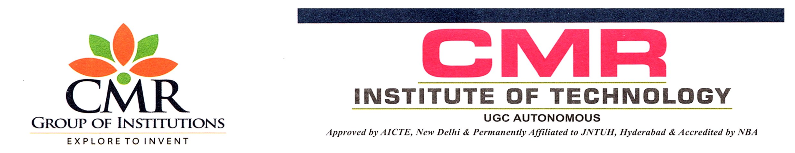

DEPARTMENT OF COMPUTER SCIENCE & ENGINEERING

AGILE METHODOLOGIES

Mid – I Assignment Questions

III– B. TECH II SEM

**SET-1**

1. Explain the Iterative and Incremental development in Agile?
2. Explain the difference between the traditional Waterfall model and Agile model?
3. Explain Lean software development?
4. Compare Extreme Programming with Scrum framework in agile approach?
5. What is Agile Knowledge Management?

**SET-2**

1. What are the principles behind the agile manifesto?
2. What do you mean by agile software development?
3. Define Agile Scrum.What are its various roles?
4. What is crystal Agile Framework?
5. What is Agile decision-making, and how does it differ from traditional decision-making approaches?

**SET-3**

1. What do you mean by Agile? List agile methods and practices?
2. What is agile project life cycle and its phases?
3. Represent the three phases of Adaptive software development?
4. Explain in detail about the life cycle of Extreame programming?
5. Indicate the concepts of Earl’s KM model?

**SET-4**

1. Explain about agile design techniques and testing phases?
2. Write about agile documentations?
3. Explain about different stages of Feature Driven Development process?
4. Explain about the practices of Extreme programming?
5. What is the Institutional Knowledge Evolution Cycle, and why is it critical for long-term organizational success?